bioSite Project: Ideas, Style Guide, Interview, and Visual Mockups

# Selected Color Palette

|  |  |  |
| --- | --- | --- |
| Color Name | Hex Code |  |
| Deep Navy | #0B1F3A |  |
| Slate | #3B4856 |  |
| Safety Gold | #D6A300 |  |
| Steel | #9AA6B2 |  |
| Off White | #F7F7F5 |  |
| Near Black | #111318 |  |

# Visual Wireframe Mockups

## Landing Page

Header Navigation (Name | Home | About | Hobbies)

Hero Image + Headline + Intro

3 Highlight Cards

Accomplishments Timeline

Image Row with Captions

Footer with External Link

## About Page

Header Navigation

Portrait Image

Formal Bio Text

Footer

## Hobbies Page

Header Navigation

Intro Paragraph

Three Hobby Sections with Image and Description

Footer

# Interview Questions and Responses

**Where did you grow up and what was your childhood like?**I was born in Blytheville, Arkansas on an Air Force base and grew up in Sullivan, Missouri. I was raised in a traditional country environment on a farm where taking care of animals and completing daily chores was a normal part of life. When my parents divorced during my teenage years, I stepped into the role of the man of the house, which taught me responsibility at a young age.

**Who influenced you the most when you were younger?**My father influenced me the most. He was strong and hardworking, and he shaped the man I am today. My mother also had a major influence because she worked extremely hard to provide for our family.

**What values do you try to live by every day?**I try to live by my faith and beliefs. I believe in working hard, being honest, and leading my family down the right path.

**How would your friends or family describe your personality?**Strong, honest, hardworking, loyal, and dedicated.

**What motivates you to keep working toward your goals?**My family motivates me. I work hard to provide them with a good life.

**What are you most proud of in your career so far?**I am proud that I have worked hard and earned the position I hold today.

**What lessons have you learned through your work?**Say what you mean and mean what you say. Always stand by your work and your word.

**What do you enjoy doing in your free time?**I enjoy working on our land and preparing it to build our new home. I also enjoy hunting, fishing, and spending time on the lake.

**What hobbies or interests are most important to you?**Hunting, fishing, hiking, and wake surfing.

**What does a perfect weekend look like?**Sleeping in until around 7 or 8, then spending the day at the lake wake surfing and relaxing, followed by a good dinner at our favorite restaurant.

**What does family mean to you?**Family means everything to me. I live for my family.

**What accomplishments in your personal life make you proud?**I am proud of how hard I have worked to get where I am today and provide stability for my family.

**What goals do you have for the future?**To build our home, start my own sanitation company, and eventually retire.

**What kind of legacy do you want to leave?**I want to leave our land, home, and farm to our children so they can continue the dream and legacy we started.

**What is something people may not realize about you?**  
I have a big heart even though I may appear strong or serious on the outside.

**What advice would you give someone starting out?**Work hard, show up, keep your word, and stay consistent.

# Formal Bio

Daniel Davidson’s story is rooted in hard work, responsibility, and a deep commitment to family. He was born in Blytheville, Arkansas on an Air Force base and raised in Sullivan, Missouri, where he grew up in a traditional country lifestyle on a working farm. Early in life, he learned the value of discipline and responsibility by caring for animals, completing daily chores, and stepping into the role of provider for his household after his parents divorced during his teenage years.

His parents both played a strong role in shaping his character. His father modeled strength and determination, while his mother demonstrated the importance of persistence and sacrifice through her work ethic. These influences helped form the values Daniel carries today, including honesty, loyalty, and a commitment to leading his family with faith and integrity.

Throughout his career, Daniel has taken pride in earning his success through consistent effort. He believes strongly in standing by his word and holding himself accountable for the work he produces. His motivation has always been rooted in his desire to provide stability and opportunity for his family.

Outside of work, Daniel enjoys spending time outdoors. He values working on family land, preparing for future plans to build a home, and enjoying activities such as hunting, fishing, hiking, and wake surfing on the lake. His vision for the future includes building a lasting legacy by creating something meaningful that can be passed down to his children.

Although he often presents a strong exterior, those close to him know he has a deeply caring nature. His life reflects dedication, resilience, and a belief that success is built through showing up every day and doing the work.

# Images

Hobby Images

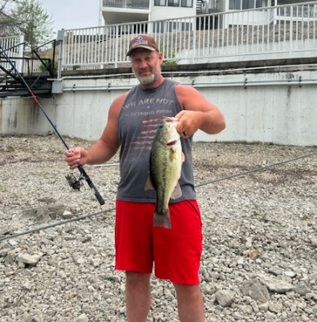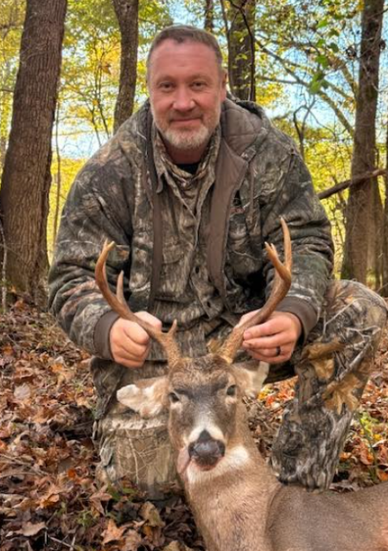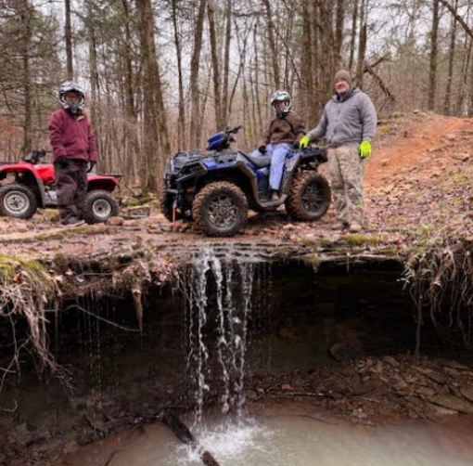

Goals/Accomplishment Images

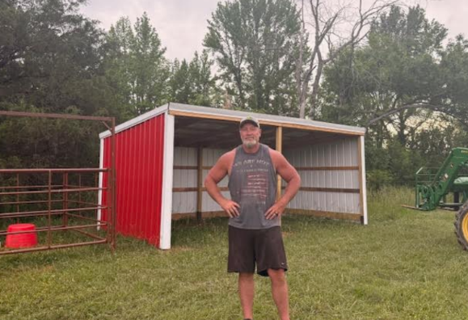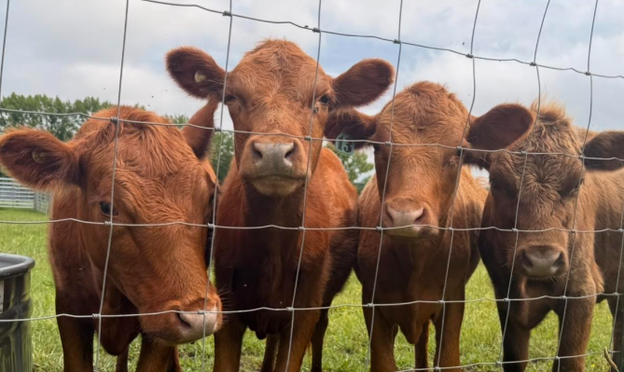

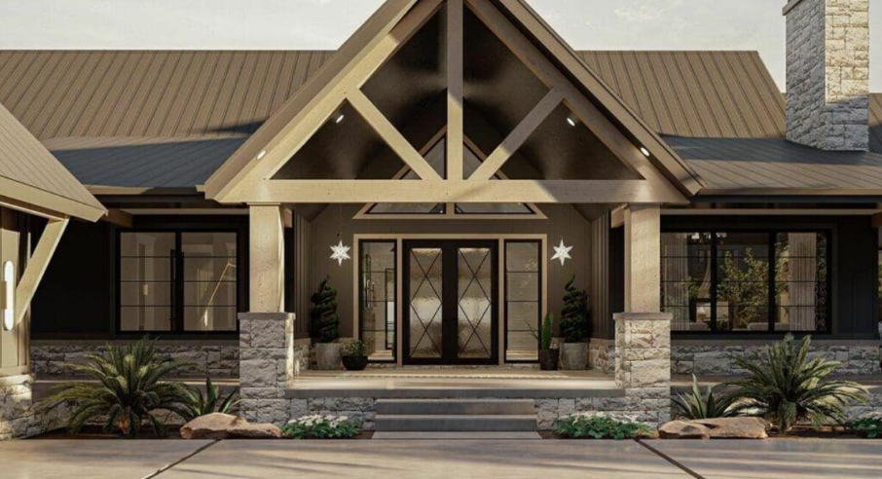

Portrait

